CIVET compilation and installation guide

DOC. No.: | REV.: 00 |  |  | PRODUCT: SL1000
TITLE: CIVET compilation and installation guide |  |  |  | Project:
Prepared by: | Lewis Chen |  |  | Date: | 2009.6.29
Remark: | Approval:
Remark: |  | Department | Title |  |  | Signature
Remark: | 1 | Electronic R&D
Remark: | 2
Remark: | 3
Remark: | 4

Revision | Description of Change | Author | Date
V0.0 | Create this document. | Lewis Chen | 2009.6.29
V0.1 | Modify this file for software change | Lewis Chen | 2009.9.27
V0.1 | Update document | Lewis Chen | 2010.1.27
V0.2 | Rename to CIVET compilation and installation guide | Donald Huang | 2010-08-25
V0.2.1 | Update file for CIVET setting up. | Lewis Chen | 2010.08.25

1. Overview 4
2. Main-board setting 4
2.1. Step1→compile ASStream.sln Project 4
2.2. Step2→compile vendui.sln Project 4
2.3. Step3→write a startup.bat file 4
2.4. Step4→copy files to main-board Nandflash disc. 4
2.5. Step5→copy database files to vendui directory 5
2.6. Step6→copy vendui.exe to vendui directory 5
2.7. Step7→copy necessary dll files to vendui driectory 5
2.8. Step8→compile ST project, then run it. 5
3. IO-software location 6
4. PC tools introduction 6
4.1. Service Tools (ST) 6
4.1.1. What is Service Tools? 6
4.1.2. The menu of ST 7
4.2. MachineDesigner 7
4.2.1. What’s MachineDesigner? 7
4.2.2. The menu of MachineDesigner 7
Appendix 9

Overview
This document is to introduce SL new software system and how to set up the whole system. In this document, there are 3 parts included:
- Main-board setting up
- IO-software introduction
- PC tools introduction

Main-board setting
To setup Main-board, 5 steps have to be finished.

Step1→compile ASStream.sln Project
Project location:
http://10.10.0.11/source/trunk/GVMC/BUS/ASStream
After compiling this project, ASStream.dll file can be got.


Step2→compile vendui.sln Project
Application on touch panel
vendui Project location:
http://10.10.0.11/source/trunk/GVMC/vendui
After compiling this project, vendui.exe file can be got.

PS:
1. The follow SDK file has to be installed first.
Location: http://10.10.0.11/source/trunk/BSP/S3C6410BSP/75600/75600/SDKs

2. Do remind that the 75600_SDK(ARMV4I) has to be selected.
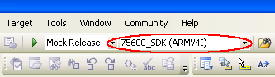

Step3→write a startup.bat file
In order to communicate with IO-board, vendui.exe must run firstly when the main-board is power up. The startup.bat is the file which will be called when the main-board is power up to execute this application.

The content of this file is as follow:
start \NandFlash\vendui\vendui.exe

Step4→copy files to main-board Nandflash disc.
Use Microsoft ActiveSync to copy the following files to main-board Nandflash disc
- ASStream.dll
- startup.bat
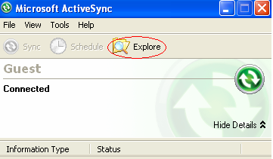
ActiveSync location: G:\Electronics\Software\Tools\ActiveSync_4_5.msi

Step5→copy database files to vendui directory
Use Microsoft ActiveSync to copy the following files to vendui directory which locates at main-board Nandflash disc
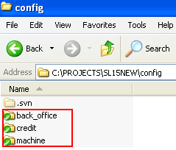

The database files location:
http://10.10.0.11/source/trunk/config

Step6→copy vendui.exe to vendui directory
Use Microsoft ActiveSync to copy vendui.exe to main-board Nandflash disc

Step7→copy necessary dll files to vendui driectory
For debug revision:
C:\Program Files\Microsoft Visual Studio 8\VC\ce\Dll\armv4i\msvcr80d.dll
(QT_DIR)\lib\QtCored4.dll
(QT_DIR)\lib\QtGuid4.dll
(QT_DIR)\lib\QtXmld4.dll
(VENDUI_DIR)\quazipd.dll

For release revision:
C:\Program Files\Microsoft Visual Studio 8\VC\ce\Dll\armv4i\msvcr80.dll
(QT_DIR)\lib\QtCore4.dll
(QT_DIR)\lib\QtGui4.dll
(QT_DIR)\lib\QtXml4.dll
(VENDUI_DIR)\quazip.dll

Step8→compile ST project, then run it.
Project location:
http://10.10.0.11/source/trunk/tools/st
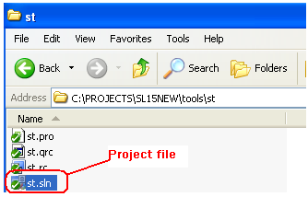
After compile ST(Service Tool) project, ST.exe appears. Then connect main-board to PC through USB cable, double click ST.exe.
Through ST, the whole machine can be control.
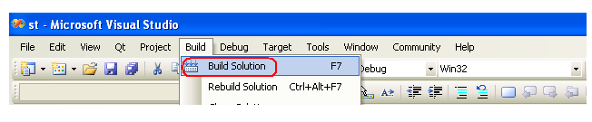
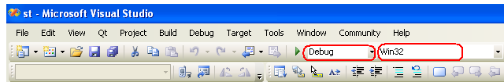

IO-software location
SL1000 project location:
http://10.10.0.11/source/trunk/SVMC/test

PC tools introduction

Service Tools (ST)

What is Service Tools?
ST is a PC tool to control the whole machine through bus between main-board and PC. With the use of ST, the whole system can be controlled.

The menu of ST


After press the Parameter button, the following menu will appear. In the follow menu, the component parameter can be set, all products can be made.
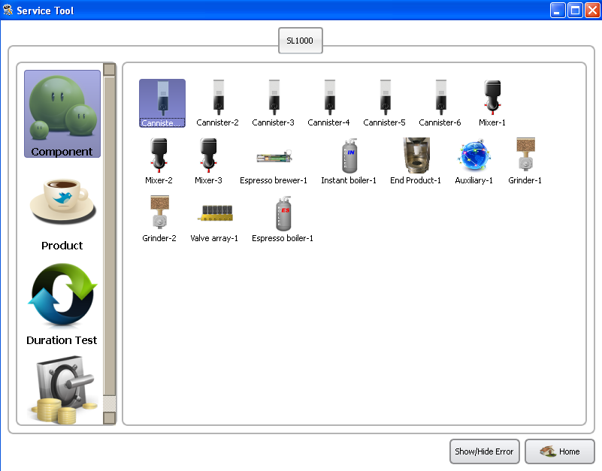

MachineDesigner

What’s MachineDesigner?
MachineDesigner is a new tool developed from ATDesigner. In other words, it’s a new version of ATDesigner. Easier to use, and more powerful.

The menu of MachineDesigner
There are two parts in MahineDesigner.

As the following shows:
- Machine Editor
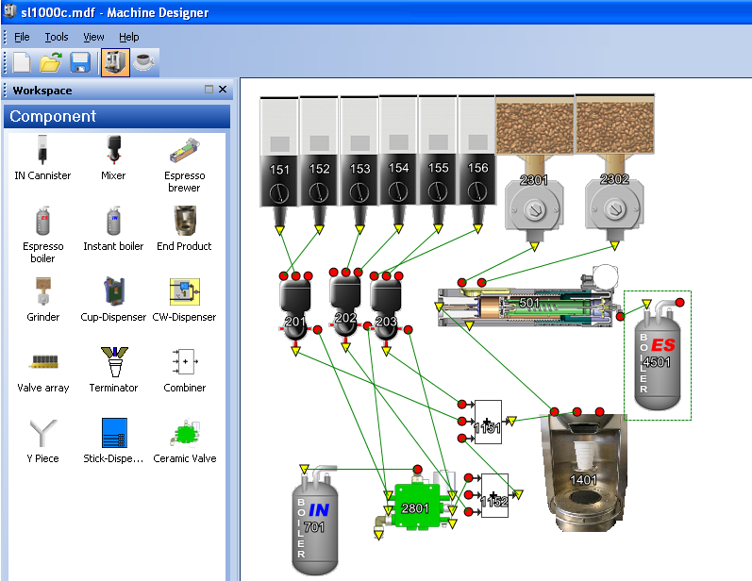

- Product Editor
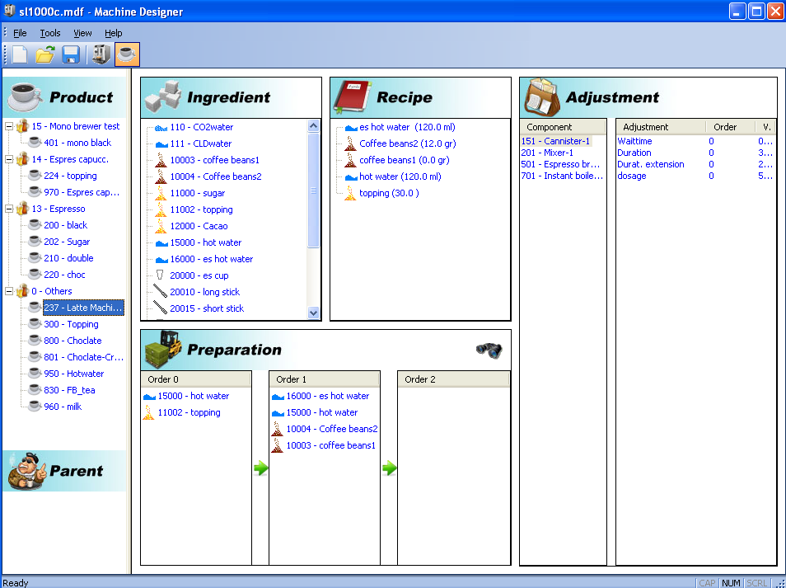

Appendix
About AdjustmentEditor (Obsolete)
  - What’s AdjustmentEditor?
AdjustmentEditor is a PC tool which controls the whole machine through bus between PC and main-board. AdjustmentEditor is the father of Service Tool (ST).
  - AdjustmentEditor menu introduce
There are 3 branches in AdjustmentEditor.
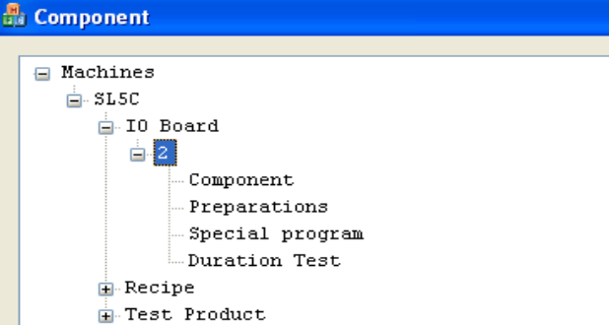

As the following pictures show:
The IO-Board branch
In this branch, all components parameters can be set.
The recipe branch
In this branch, all the recipe of product can be set.
The test Product branch
In this branch, all products can be test.
  - Compile AdjustmentEditor
Project location:
http://10.10.0.11/source/trunk/admin/AdjustmentEditor/Project
Please remember that the solution configuration must
select ‘ASBUF DEBUG’.
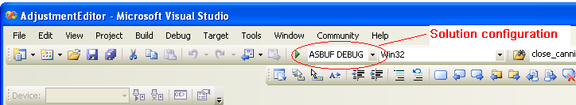
After compile AdjustmentEditor project, AdjustmentEditor.exe
appears. Then connect main-board to PC through USB cable,
double click AdjustmentEditor.exe. Through AdjustmentEditor, the
whole machine can be controled.
How to compile ST?
Development environment setting
In order to compile ST project, the following steps should be finish. After finishing the following step, the ST project can be compiled.
a. Get the source of the Qt and uncompress it to certain directory, such as "C:\qt-win32-4.6.0" \\10.10.0.11\dev\software\libs\QT\qt-everywhere-opensource-src-4.6.0.tar.gz

b. Copy "./mkspecs/win32-msvc2005" to "C:\qt-win32-4.6.0\mkspecs"

c. Copy "config-win32.bat" to "C:\qt-win32-4.6.0"

d. If you want to get the help document of Qt (NOTE: It would take a long time, necessary for Qt developer)
{
Copy "build-win32-full.bat" to "C:\qt-win32-4.6.0
Goto "C:\qt-win32-4.6.0"
Run "build-win32-full.bat"
}
else
{
Copy "build-win32-small.bat" to "C:\qt-win32-4.6.0
Goto "C:\qt-win32-4.6.0"
Run "build-win32-small.bat"
}

e. If you want to compile st (Service Tool)
{
a). Get the source of the Qt's property browser framework
and uncompress it to certain directory.
Such as C:\qtpropertybrowser-2.5-opensource:
\\10.10.0.11\dev\software\libs\QT\QtSolutions\qtpropertybrowser-2.5-opensource.zip
b). Goto "C:\qtpropertybrowser-2.5-opensource"
c). Run "configure.bat -library"
d). Run "C:\qt-win32-4.6.0\bin\qmake && nmake"
}
f. Install QT's addin for Visual Studio 2005
Location:
\\10.10.0.11\dev\software\libs\QT\qt-vs-addin-1.0.1.exe
g. Set QT path in "Visual Studio 2005"
Qt->Qt Options->Add
Version name : 4.6.0
Path: C:\qt-win32-4.6.0

